## Batch: B4 Experiment Number: 7

**Roll Number: 16010421119 Name: Aarya Tiwari**

## Aim of the Experiment:

Study of Netica Software (free version) and use of it to build a small Bayesian Network

## Program/ Steps:

1. Consider the Bayesian Network Diagram given below containing six random variables: "Burglary", "Earthquake", "Alarm", "JohnCalls", “ MaryCalls” and “Radio Announcement”.

In this, "Burglary" and "Earthquake" are independent, and "Burglary" and "Radio Announcement" are independent given "Earthquake." This is to say that there is no event that affects both burglaries and earthquakes.

As well, "Burglary" and "Radio Announcements" are independent given "Earthquake" - meaning that while a radio announcement might result from an earthquake, it will not result as a repercussion from a burglary.

1. Create a Bayesian Network using Netica (free version) and explore the functions of Netica on the created network.

## Output/Result:

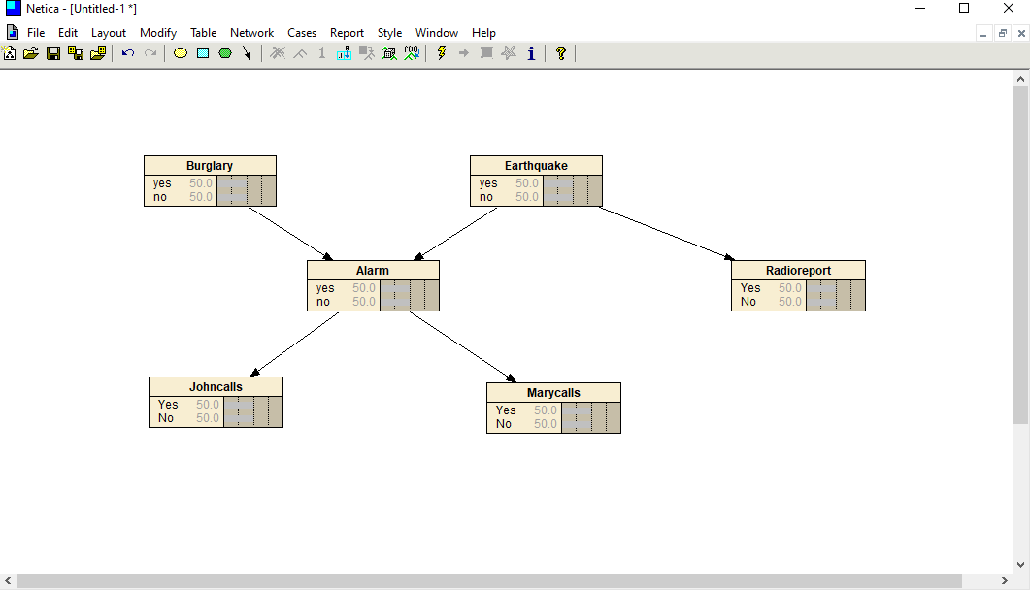

**Post Lab Question-Answers:**

# Q1. List the features of Netica

* Compiles Bayes nets into junction trees of cliques for fast probabilistic reasoning.
* Can learn probabilistic relations from data (including EM and gradient descent learning).
* Generates presentation quality graphics which can be transferred to other documents, including SVG graphics.

# Q2. State the following statements with respective to the diagrams are true or false and Justify your answer

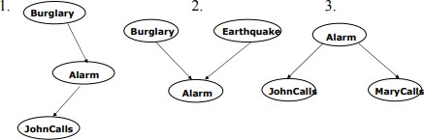

1. **JohnCalls is independent of Burglary, given Alarm**: True

# Burglary is independent of Earthquake (not knowing Alarm) but Burglary and Earthquake become dependent, given Alarm: True

1. **MaryCalls is independent of JohnCalls, given Alarm**: False

## Outcomes:

Comprehend problems with uncertainty, formalize the problem and understand how solutions are found.

## Conclusion: (based on the Results and outcomes achieved)

Through this experiment, we successfully understood Study of Netica Software (free version) and built a small Bayesian Network

## References:

* Stuart Russell and Peter Norvig, Artificial Intelligence: A Modern Approach,
* Second Edition, Pearson Publication
* https://[www.norsys.com/netica_api.html](http://www.norsys.com/netica_api.html)
* https://[www.norsys.com/tutorials/netica/nt_toc_A.htm.](http://www.norsys.com/tutorials/netica/nt_toc_A.htm)